Test Case: tc001_SPX_Dev5_Crear_Requisicion_Spot_Tipo_Cobro_CC
Step 1 - Enter username and password and click to button Enter : Credentials Entered
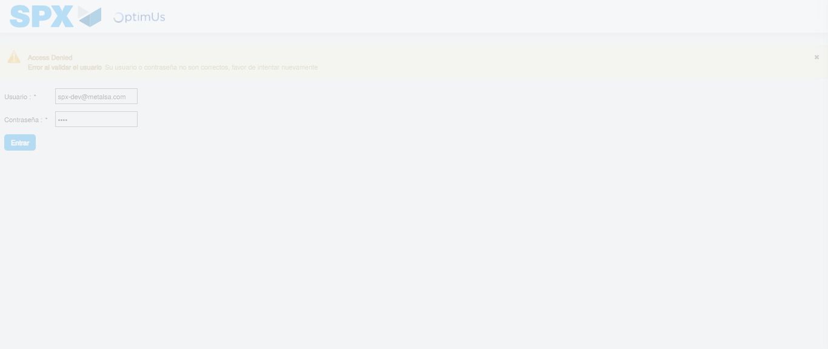Image file-name: QC_Testing-tc001_SPX_Dev5_Crear_Requisicion_Spot_Tipo_Cobro_CC-1782255793772

Step 2 - Select to UEN and Access to Spot Buy Requisitions : UEN Correctly selected and Correct access
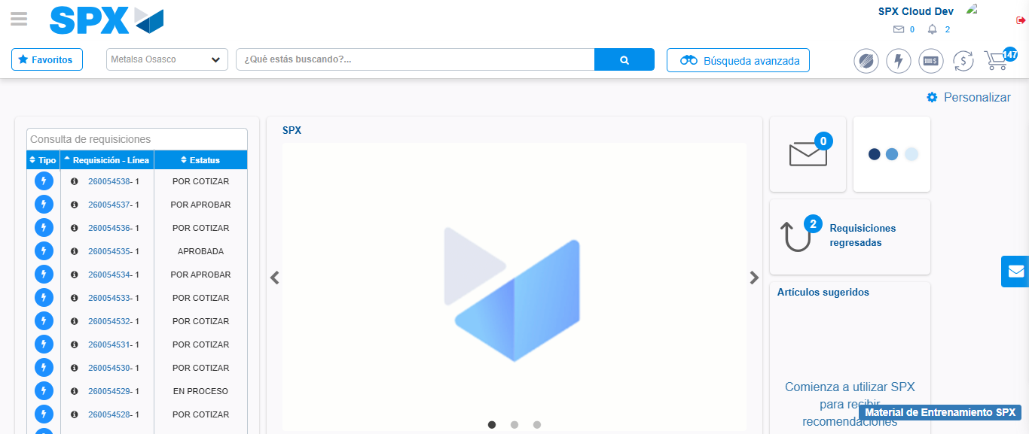Image file-name: QC_Testing-tc001_SPX_Dev5_Crear_Requisicion_Spot_Tipo_Cobro_CC-1782255820431

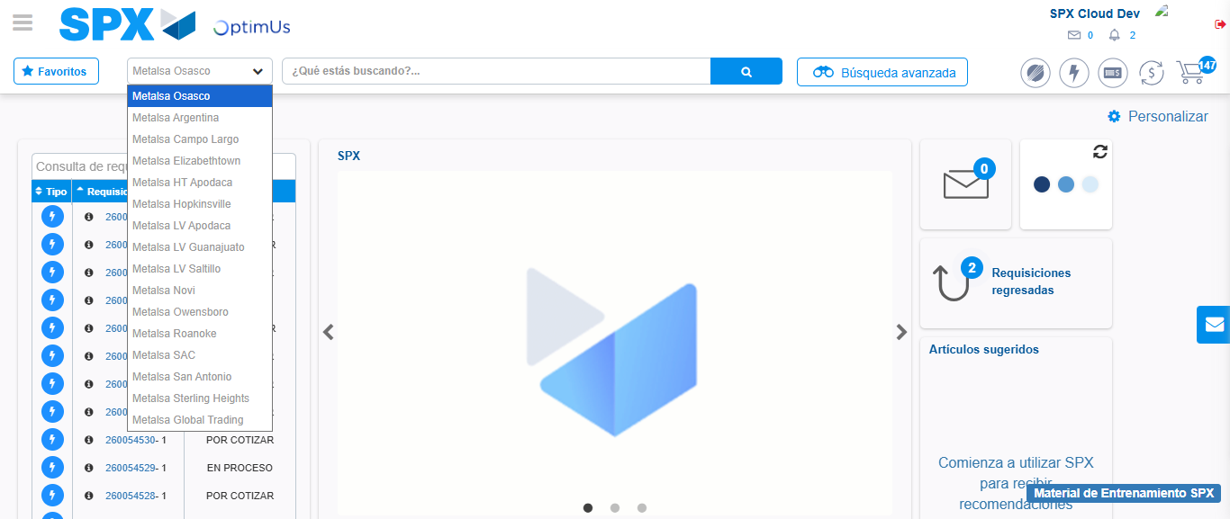Image file-name: QC_Testing-tc001_SPX_Dev5_Crear_Requisicion_Spot_Tipo_Cobro_CC-1782255823236

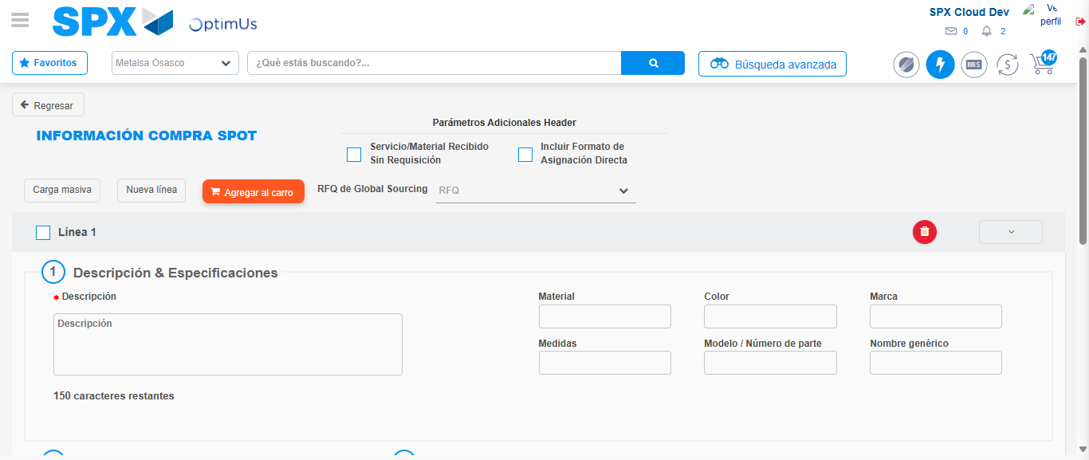Image file-name: QC_Testing-tc001_SPX_Dev5_Crear_Requisicion_Spot_Tipo_Cobro_CC-1782255843444

Step 3 - Data Capture Spot Buy Requisition : Data captured correctly
Image file-name: QC_Testing-tc001_SPX_Dev5_Crear_Requisicion_Spot_Tipo_Cobro_CC-1782255843751

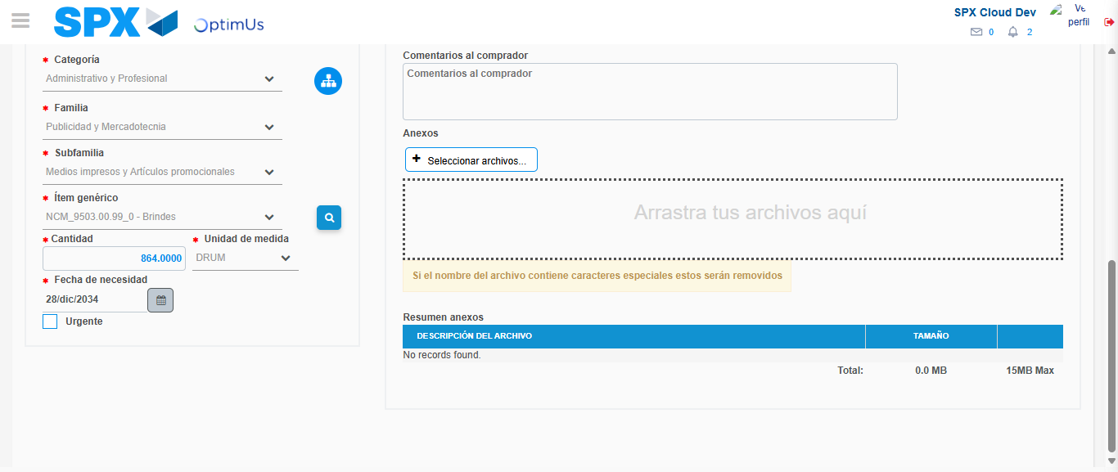Image file-name: QC_Testing-tc001_SPX_Dev5_Crear_Requisicion_Spot_Tipo_Cobro_CC-1782255857077

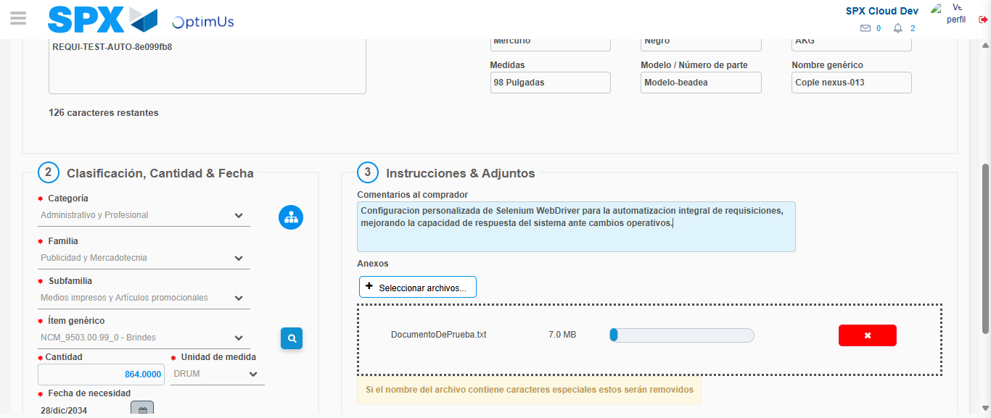Image file-name: QC_Testing-tc001_SPX_Dev5_Crear_Requisicion_Spot_Tipo_Cobro_CC-1782255858014

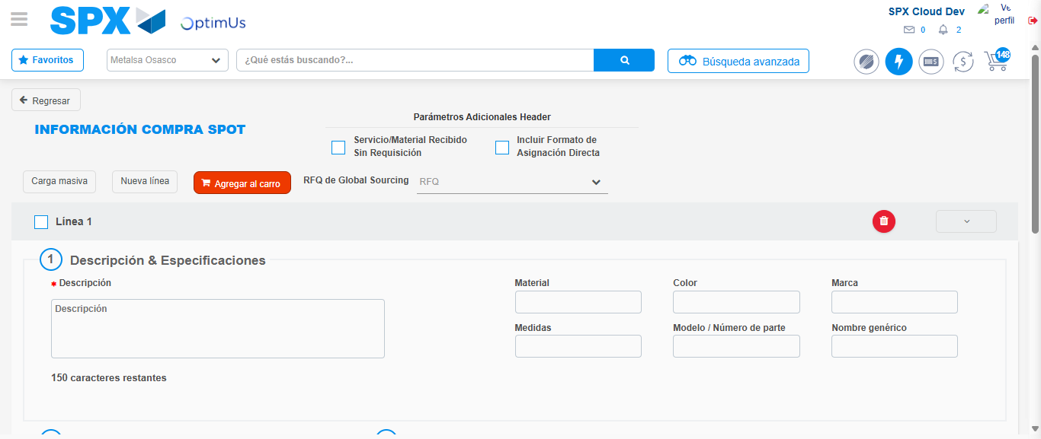Image file-name: QC_Testing-tc001_SPX_Dev5_Crear_Requisicion_Spot_Tipo_Cobro_CC-1782255871084

Step 7 - Return to Main Page SPX : Return to Main Page SPX
Image file-name: QC_Testing-tc001_SPX_Dev5_Crear_Requisicion_Spot_Tipo_Cobro_CC-1782255820431

Image file-name: QC_Testing-tc001_SPX_Dev5_Crear_Requisicion_Spot_Tipo_Cobro_CC-1782255823236

Image file-name: QC_Testing-tc001_SPX_Dev5_Crear_Requisicion_Spot_Tipo_Cobro_CC-1782255843444

Image file-name: QC_Testing-tc001_SPX_Dev5_Crear_Requisicion_Spot_Tipo_Cobro_CC-1782255873342

Image file-name: QC_Testing-tc001_SPX_Dev5_Crear_Requisicion_Spot_Tipo_Cobro_CC-1782255873545

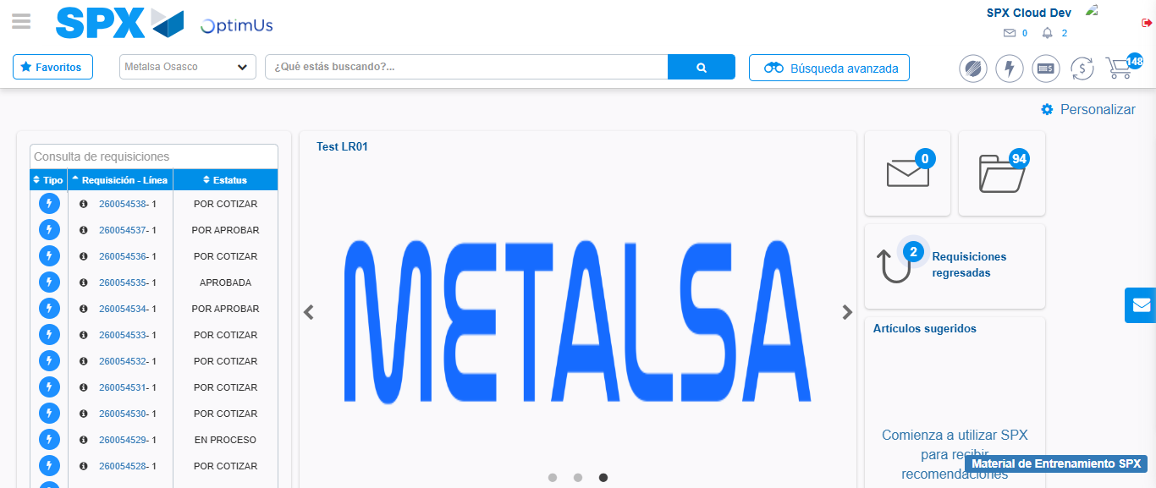Image file-name: QC_Testing-tc001_SPX_Dev5_Crear_Requisicion_Spot_Tipo_Cobro_CC-1782255895010

Step 8 - Log Out : Log Out SPX
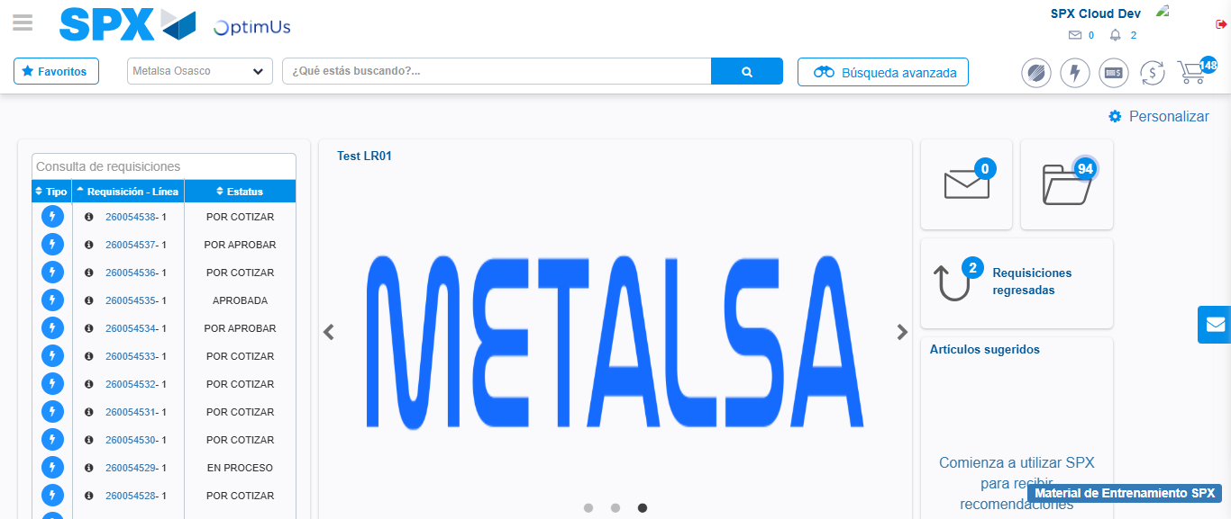Image file-name: QC_Testing-tc001_SPX_Dev5_Crear_Requisicion_Spot_Tipo_Cobro_CC-1782255895365

